**Assignment Advance Programming Lab 3**

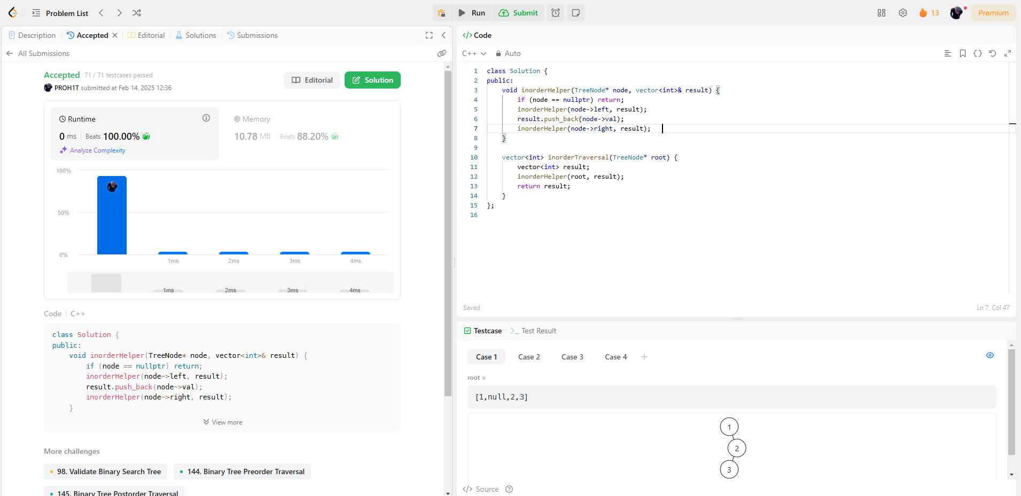**94.**[**Binary Tree Inorder Traversal**](https://leetcode.com/problems/binary-tree-inorder-traversal/)

**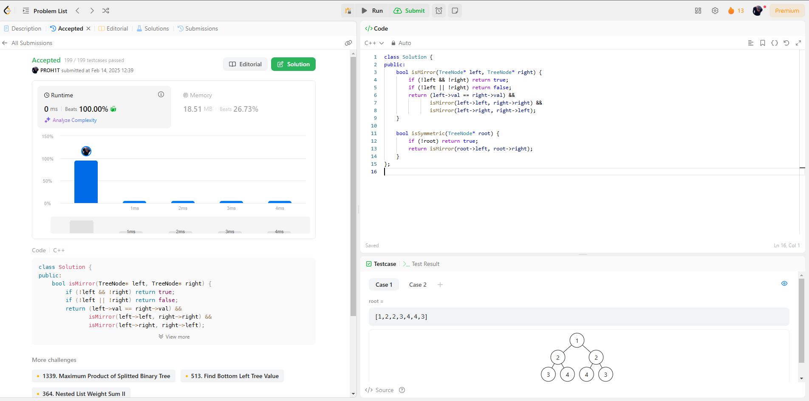  
101.**[**Symmetric Tree**](http://leetcode.com/problems/symmetric-tree/description/)

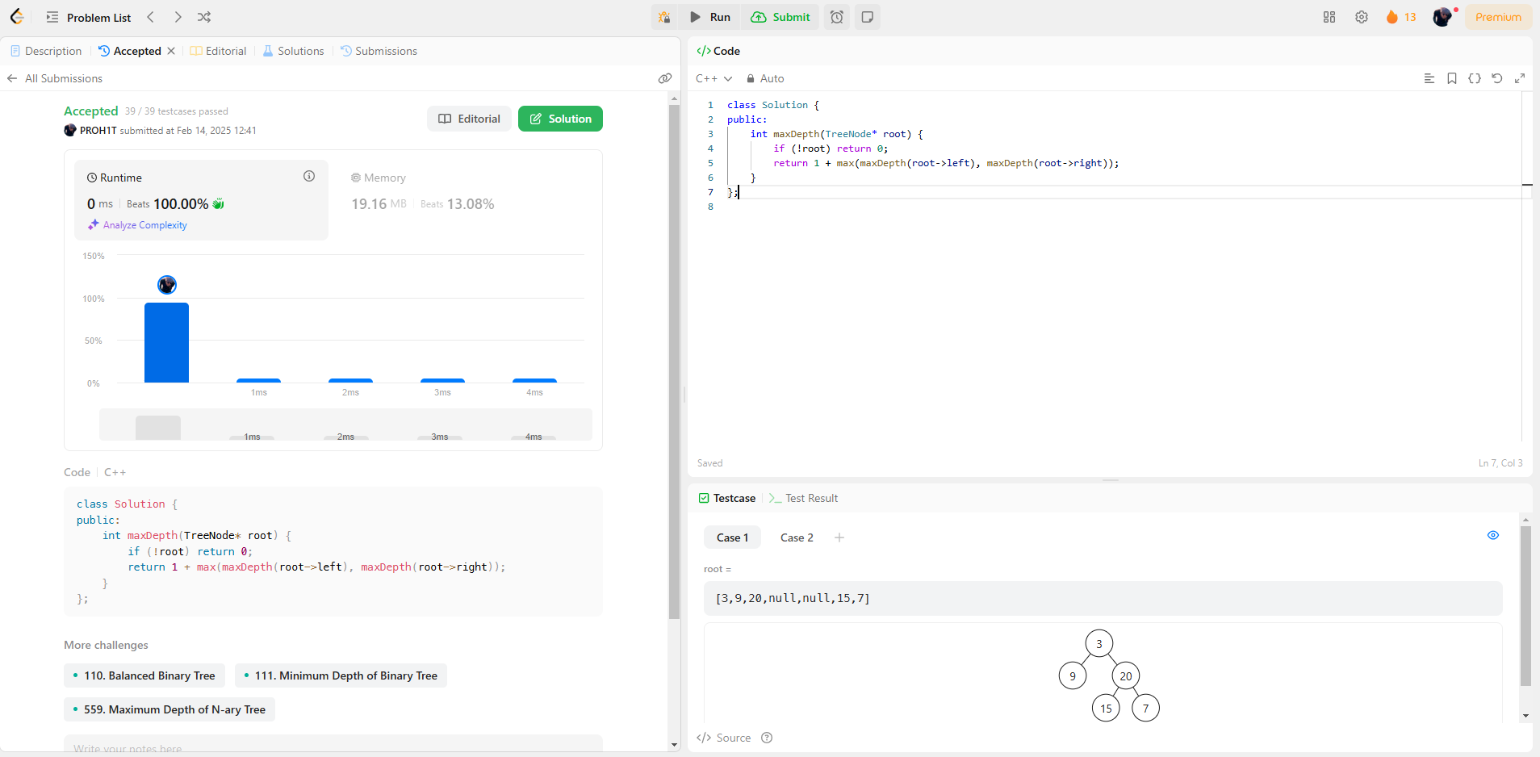**104.**[**Maximum Depth of Binary Tree**](https://leetcode.com/problems/maximum-depth-of-binary-tree/description/)

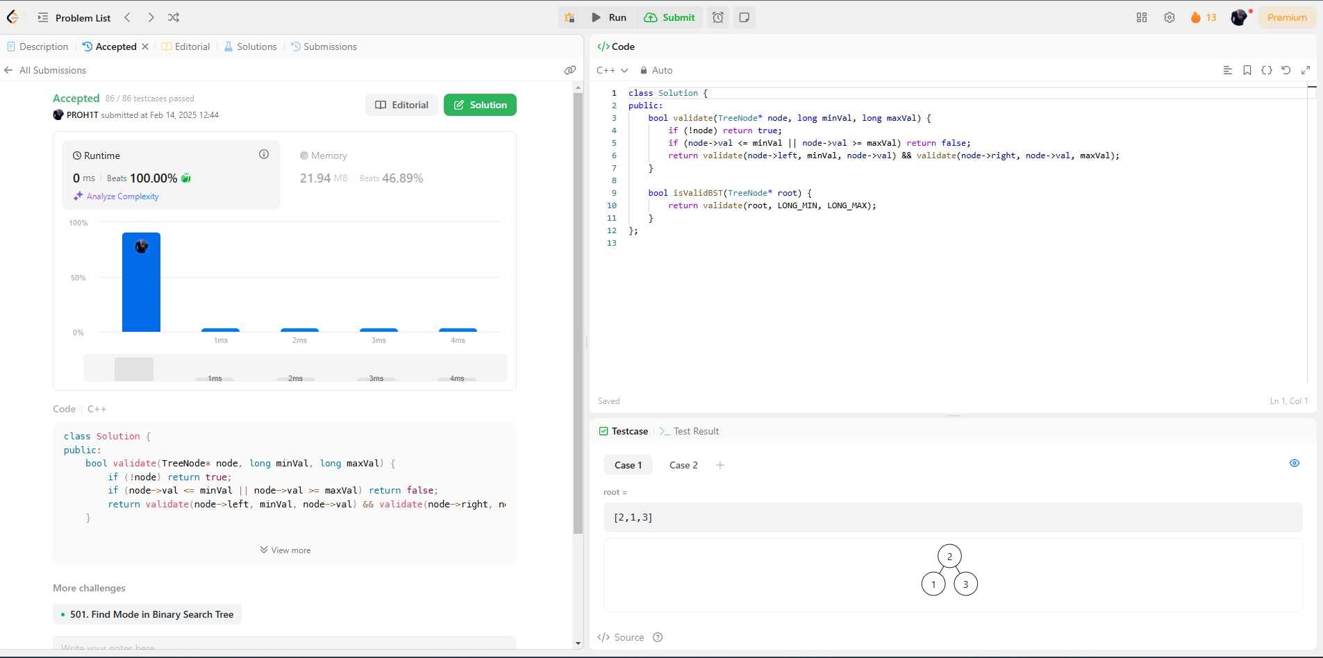**98.**[**Validate Binary Search Tree**](https://leetcode.com/problems/validate-binary-search-tree/description/)

**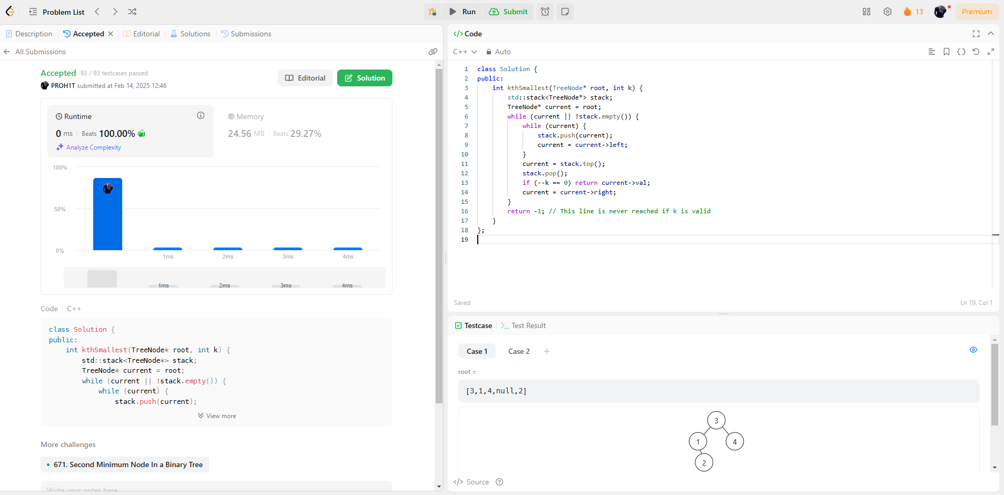  
230.**[**Kth Smallest Element in a BST**](https://leetcode.com/problems/kth-smallest-element-in-a-bst/description/)

**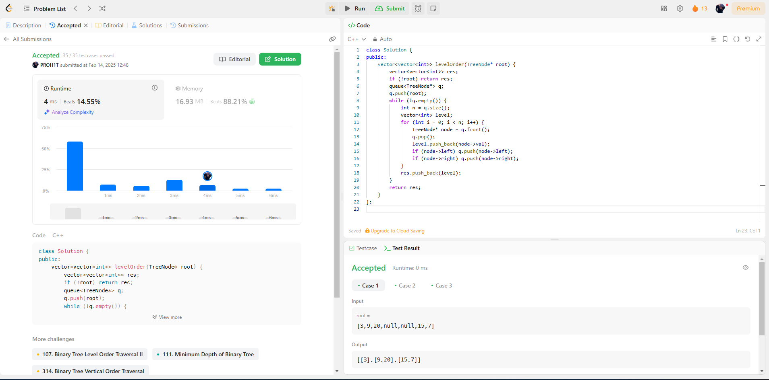  
102.**[**Binary Tree Level Order Traversal**](https://leetcode.com/problems/binary-tree-level-order-traversal/description/)

**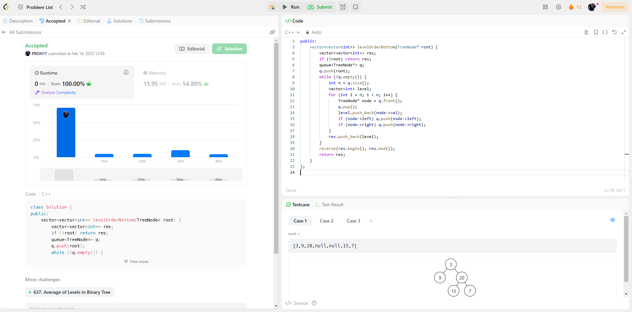  
107.**[**Binary Tree Level Order Traversal II**](https://leetcode.com/problems/binary-tree-level-order-traversal-ii/description/)

**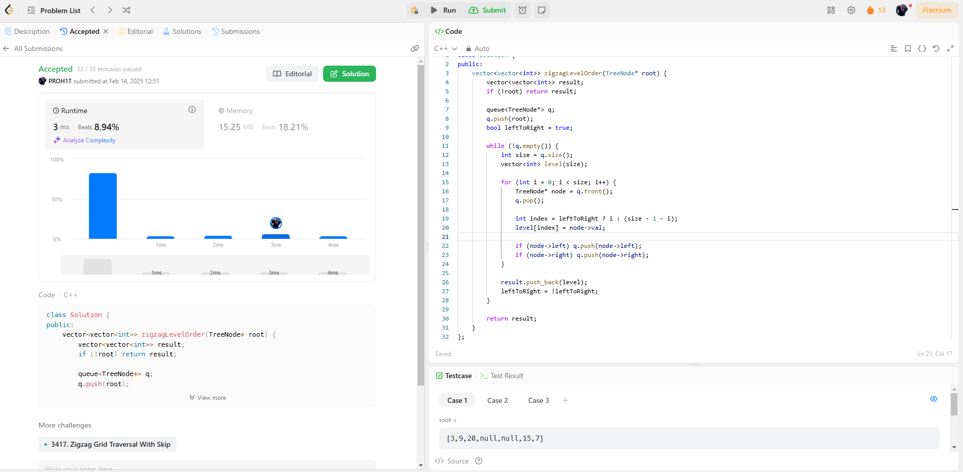  
103.**[**Binary Tree Zigzag Level Order Traversal**](https://leetcode.com/problems/binary-tree-zigzag-level-order-traversal/description/)

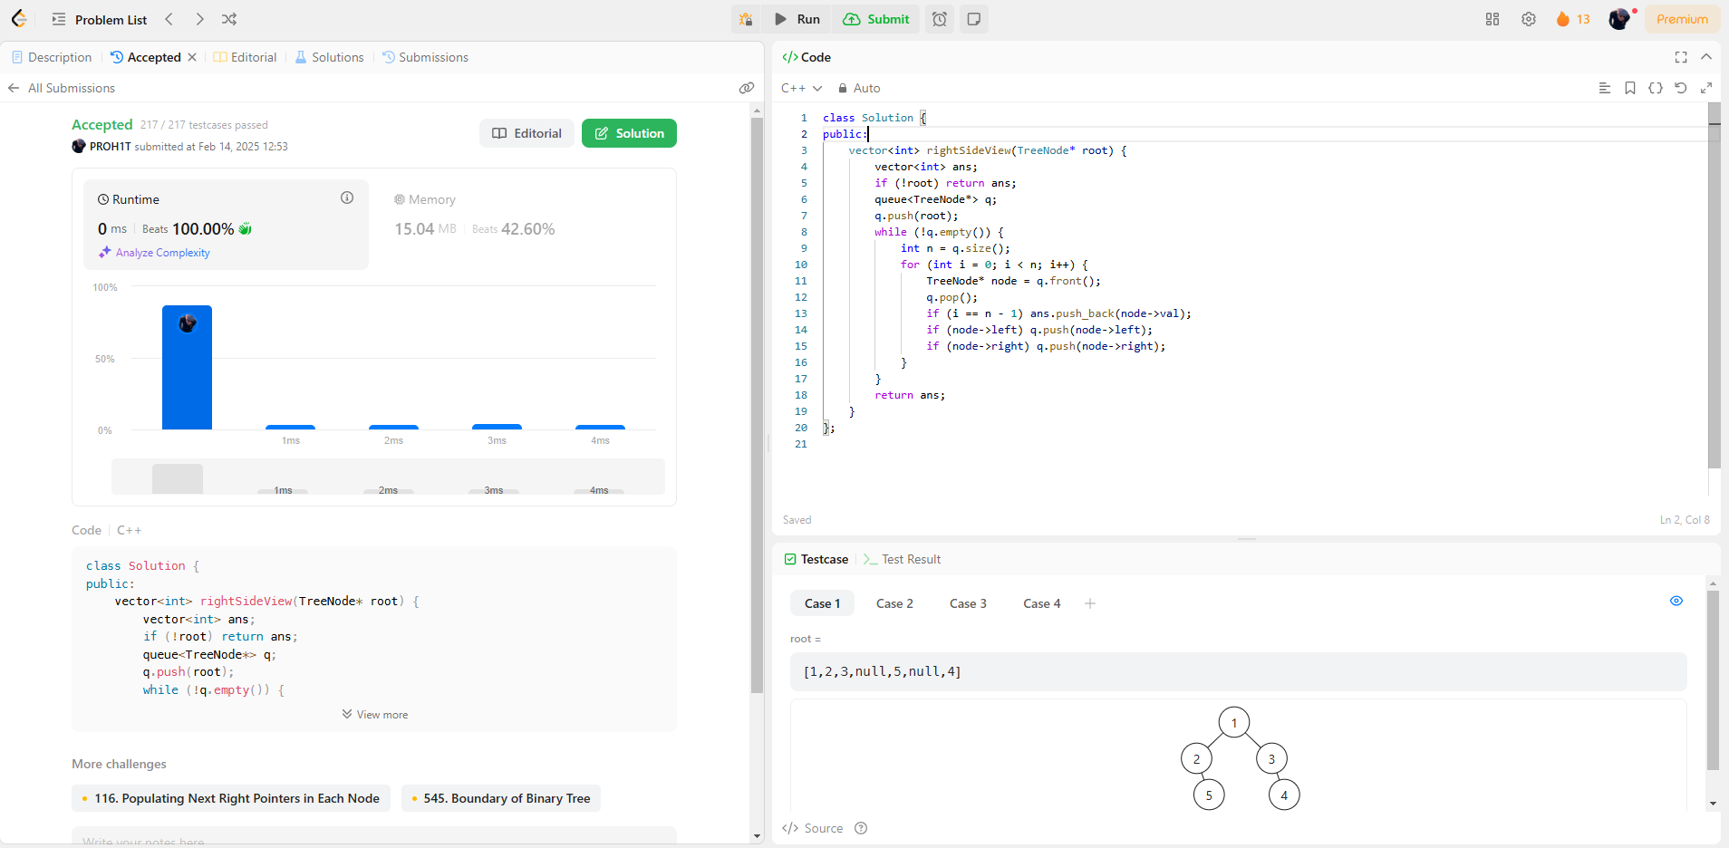**199.**[**Binary Tree Right Side View**](https://leetcode.com/problems/binary-tree-right-side-view/description/)

**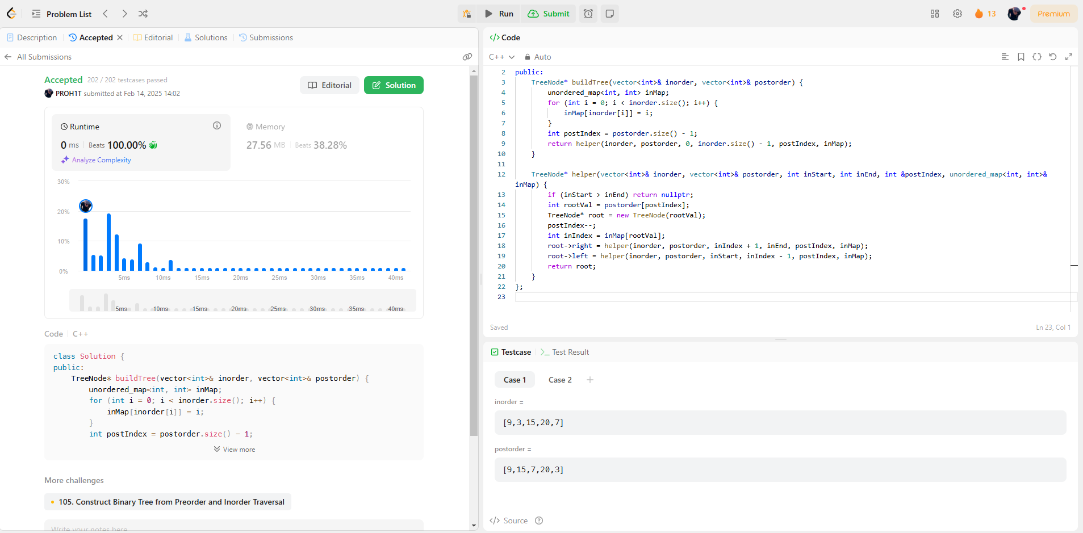  
106.**[**Construct Binary Tree from Inorder and Postorder Traversal**](https://leetcode.com/problems/construct-binary-tree-from-inorder-and-postorder-traversal/description/)

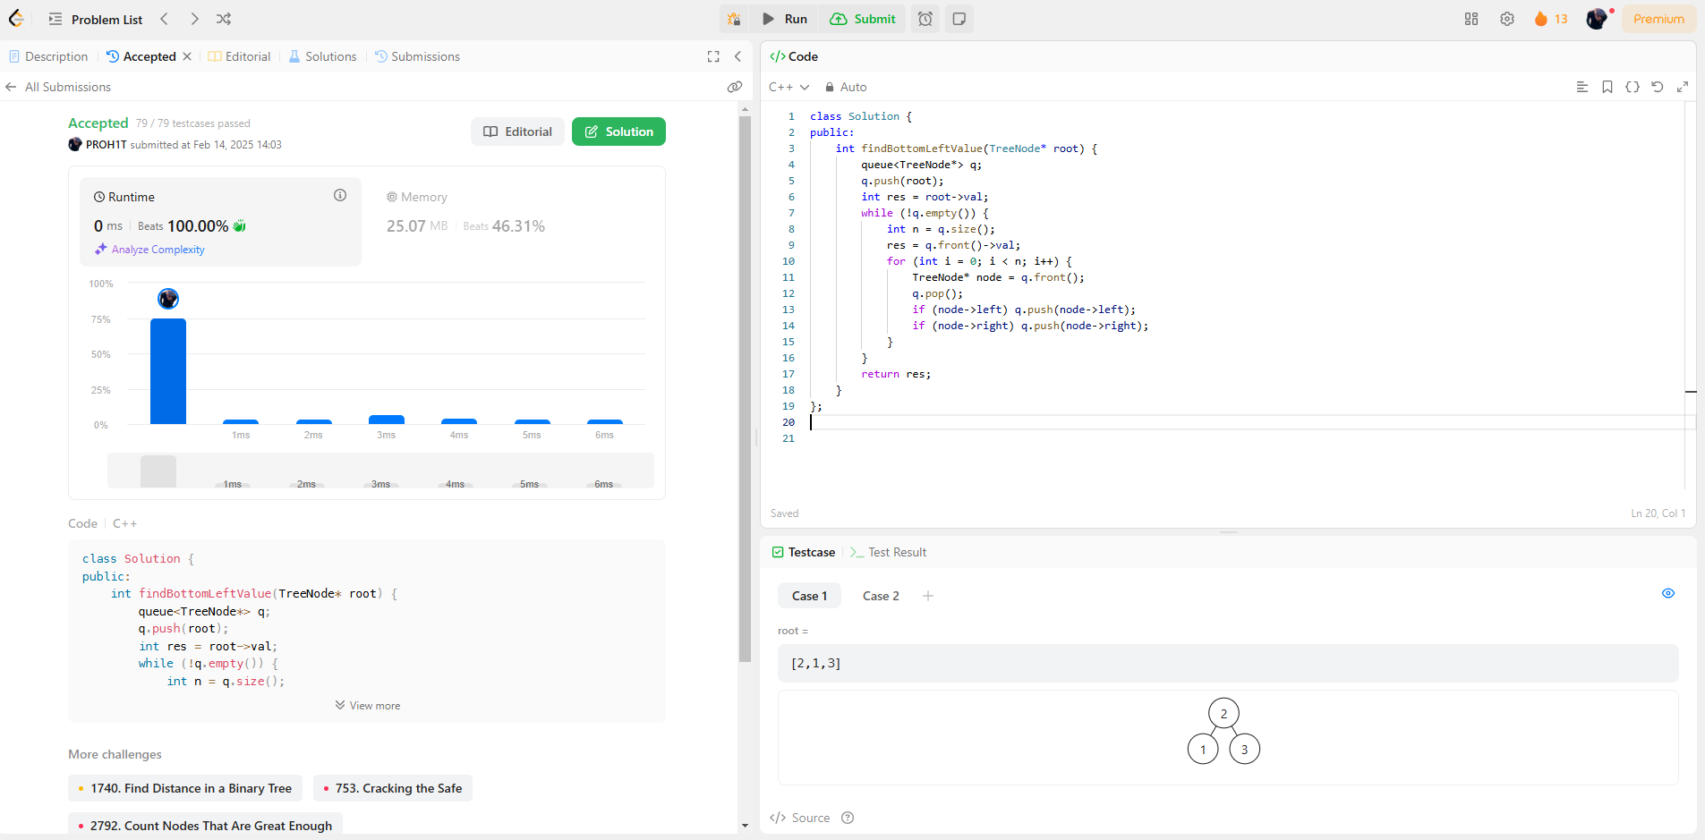**513.**[**Find Bottom Left Tree Value**](https://leetcode.com/problems/find-bottom-left-tree-value/description/)

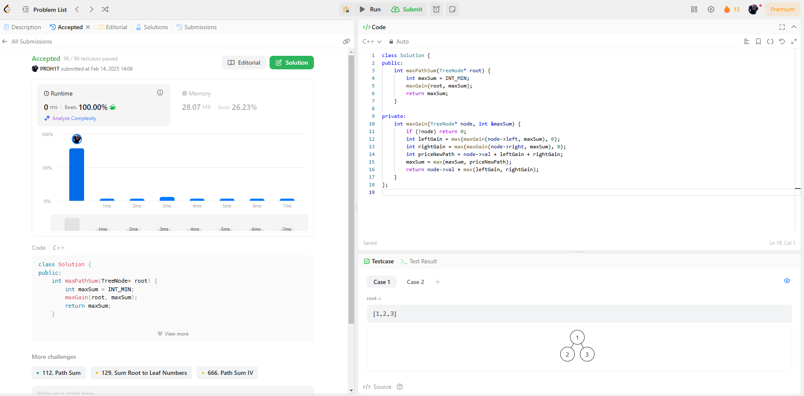**124.**[**Binary Tree Maximum Path Sum**](https://leetcode.com/problems/binary-tree-maximum-path-sum/description/)

**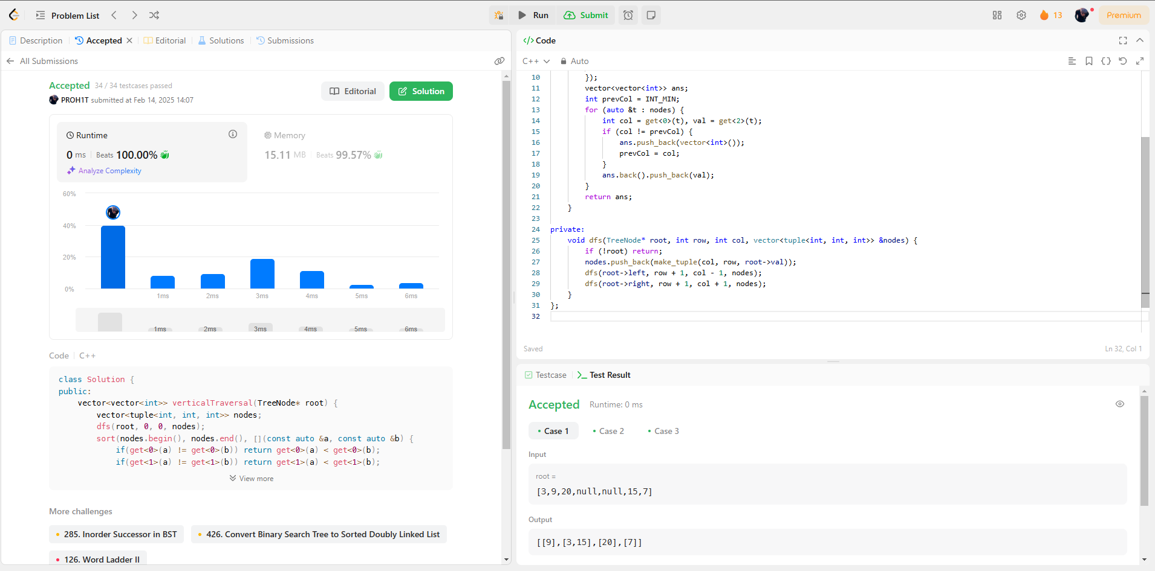  
987.**[**Vertical Order Traversal of a Binary Tree**](https://leetcode.com/problems/vertical-order-traversal-of-a-binary-tree/description/)